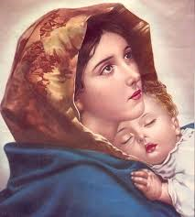
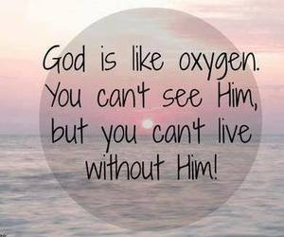
Inside This Issue
1 Editor’s Note
2 Sunday School
3 Youth
4 Adults
5 Pictures
7 Prize Quiz
Dear Readers:

The past few months have been very eventful for many of the members of our church. From the welcoming of our new Achen, Rev. Fr. Pradosh, to the annually performed Sunday School Day programs, we have quite enjoyed these various occasions. A few reminders about the upcoming events: in the month of December, lent will be coming up soon as well as the election for our New Committee Members on the 18th. Caroling will also be starting soon. In addition, if anyone would like to publish their articles in the newsletter, please feel free to contact me at reshvil28@gmail.com, or Fr. Martin at deaconmartin@gmail.com . A special thanks to all the contributors who worked and made this short-but-sweet newsletter possible. As per usual, please read, enjoy and send or let us know of any feedback.
Sincerely,
Reshma Vilson
Editor

November 27, 2016 ─ Volume 3 Issue 1

4637 West Orem Drive, Houston, TX 77045
www.stmaryschurchhouston.com

Newsletter
St. Mary’s Syrian Malankara Orthodox Church

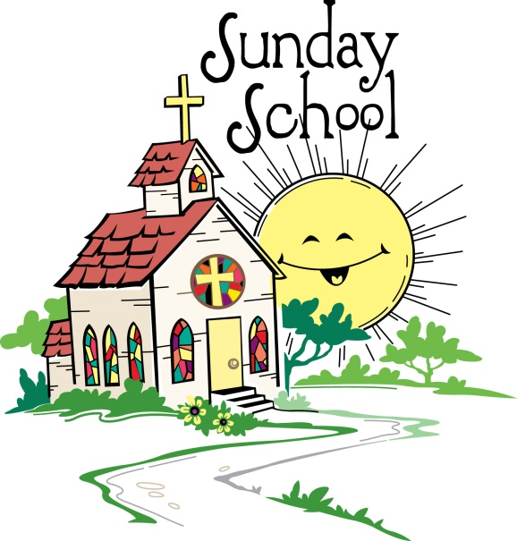
Sunday School has been very busy these previous months. In September, The Regional Sunday School Competition was held in Dallas. Our church was very successful with earning two championship trophies for our church: Annmary Thomas, Giju Shinu. We just recently had our semester exams on November 6th. The next round of exams will be held in December. The 10th Grade Exam was held on November 13th. The students had a 3 week review period. On November 25th, we had a magnificent Sunday School Day, where different students performed different types of acts. In addition to Sunday School exams, an upcoming event that will be held in the month of December will be our annual Christmas Program. Along with the usual “Birth of Jesus” (nativity) skit., many students are expected to execute diverse presentations. So far we know that the fifth grade class, taught by Mr.Biju Ittan, will be doing a skit and a group song, and the 9th Grade Class, taught by Mrs. Jessy Cecil, will be doing a skit. The other class’s acts are yet to be confirmed.
By Rahul Varghese and Basil Issac
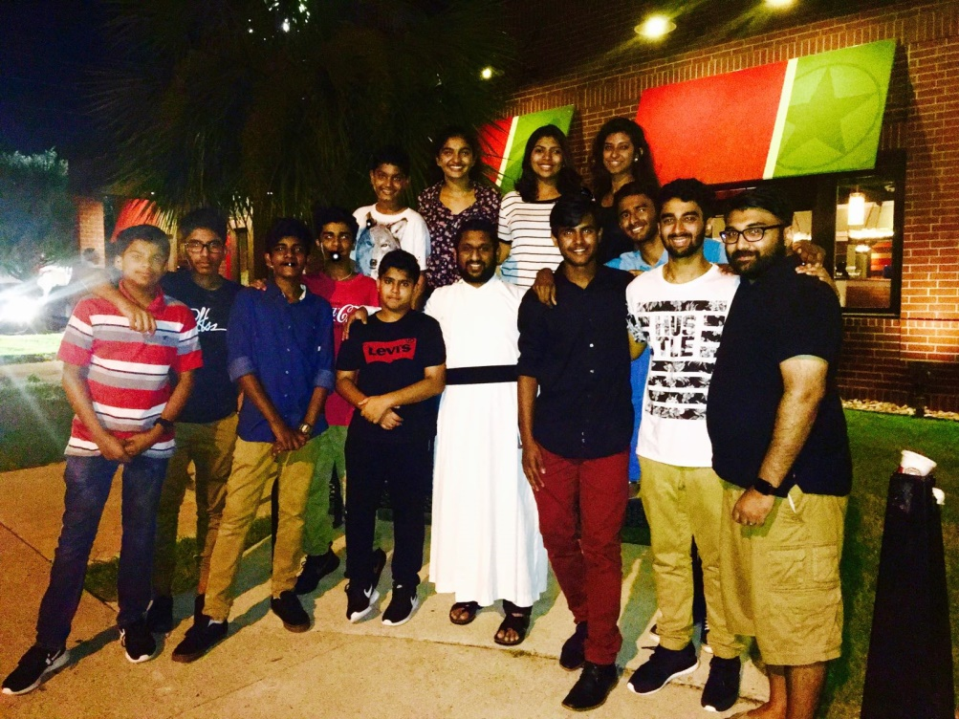
The youth at our church is very excited for the next few months. Fr. Pradosh did his first English Qurbana in our church on November 13th. The youth have been partaking in many meetings to increase their activity. Prior to the English Qurbana on the 13th, we had finalized practice days for the English Qurbana. We also decided on starting a basketball club for our church, in which anyone can participate. Although the details are not completed yet, we plan on starting soon. On November 12th, the youth had a social event welcoming for Rev. Dn. Anish Skariya’s wife, Meril Luke. As a youth, we are very much looking forward to the holiday seasons and caroling that is to start soon.

By Annu Sony

On Oct. 29, 2016, at
St. Mary’s Syrian
Orthodox Church, the Board
Adults
Of Committee and Building
Committee signed a contract regarding our new church. There was a brief meeting before signing the contract about the placement of the new church. The Contract was handed over to Trimcos, a designing and engineering firm. Coupled with that, on the last week of October, we had our usual chain prayer in which a great amount of people participated. This helped us as a family to prepare for the Parumala Thirumeni Perunnal which took place on Oct. 30th, 2016. On that day, the Qurbana was celebrated by Fr.Pradosh.Correspondingly, the St. Mary’s Women's League and The St. Paul’s Men's league conducted their first carol practice at Church. On the other hand, the young adults are still working on planning a bible study that caters to adults who want to know more about the Qurbana and why is attending Church Qurbana important. We also want to have a Qurbana study which will help us know what some parts of the Qurbana mean.

By Yohan Mathew, Ciril Vavachen and Dn. Anish
Sunday School Day

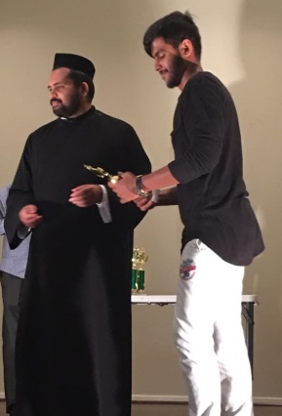
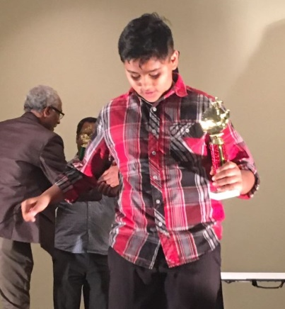
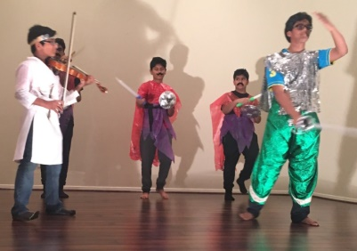
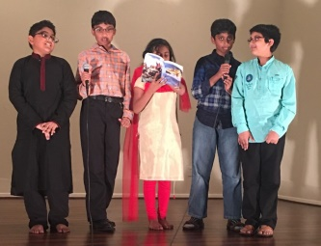
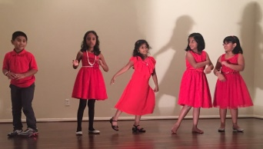
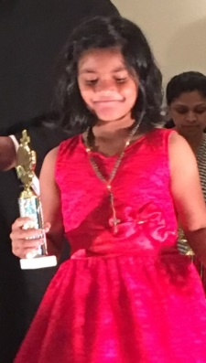
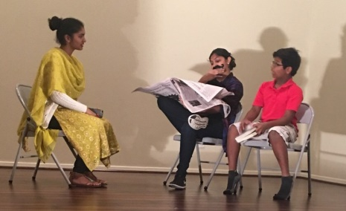
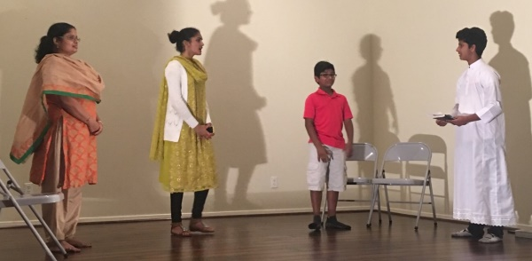
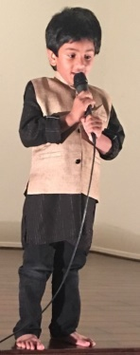
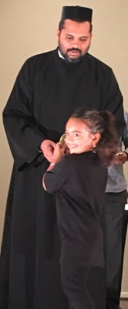
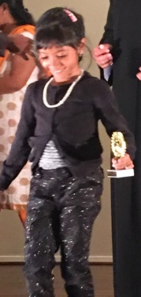
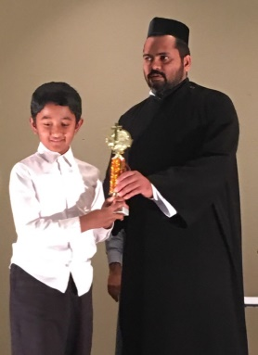
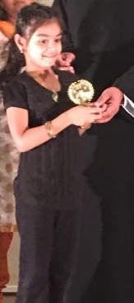
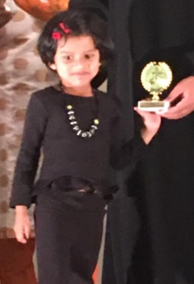
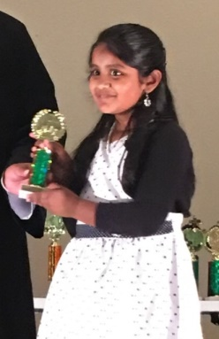
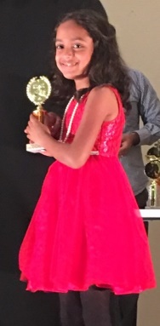
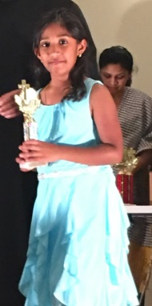
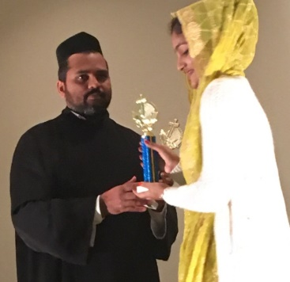
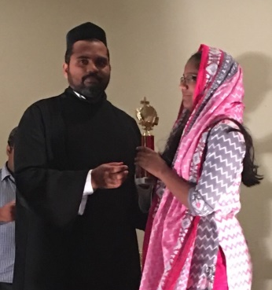
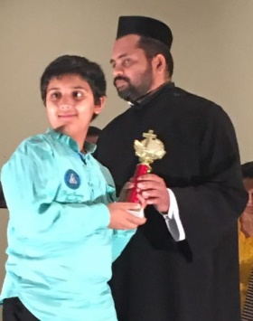
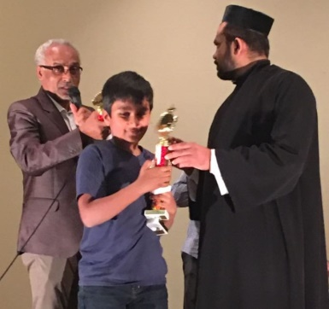
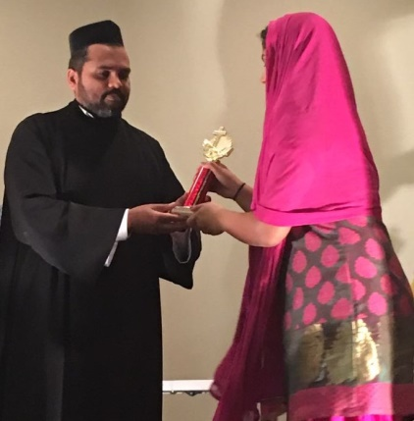
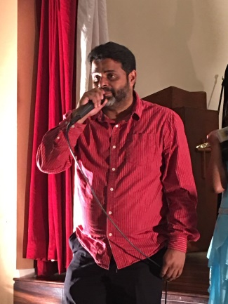
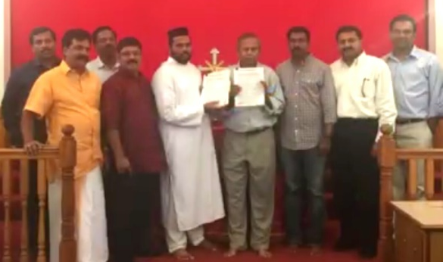
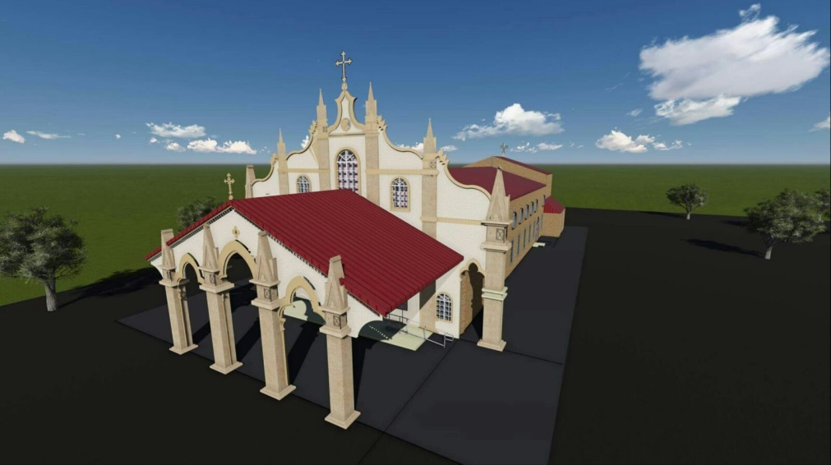
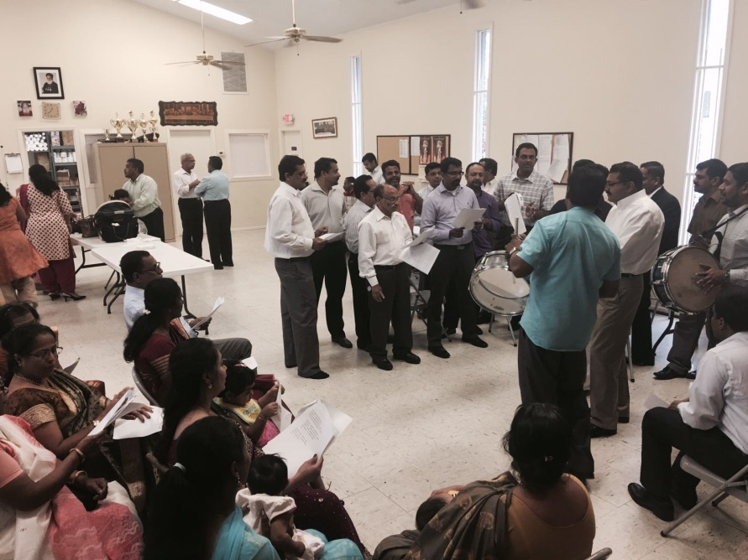
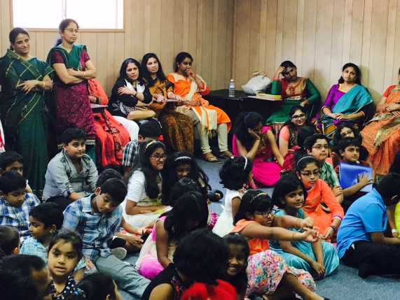
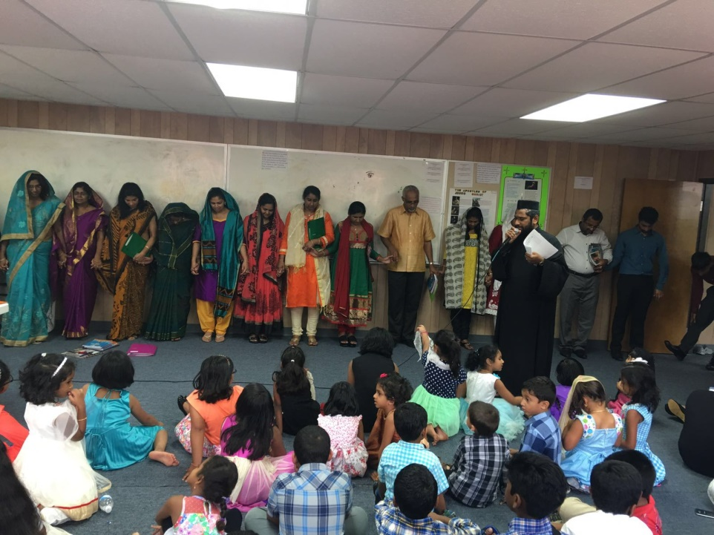
Caroling Practice
New Church
Sunday School
Credit for Quiz: Fr. Martin
Bible Quiz
- Jesus came by water and what?
- What Old Testament book gave a prophecy about baby Jesus being conceived in Mary as a virgin?
- What is the missing word of this verse in Philippians: ______ in the Lord always.
- What stirred Paul’s spirit in Athens?
- What is another kind of famine the Lord will send on Israel as penalty for deceit?
- What does it mean to offer a sacrifice with leaven (Amos 4:5)?
- For what is Hosea to rebuke Israel?
- What does the wide and broad gate lead to?
By answering these few questions, you will be able to enter your name into a drawing. Our Headmaster will randomly choose five names out of the drawing and those people will receive a surprise gift. Please turn in your answer sheets to Headmaster. All ages are allowed to participate. However there is deadline. Hurry up and do this before January 1st. Good Luck!

